Tools for Model Experimentation: Hugging Face and LangChain
In Large Language Model (LLM) development, model experimentation means selecting a pre-trained model, providing input data, running the model, observing its output, evaluating its performance, and improving the application.

1. Hugging Face
Model loading and experimentation
Provides pre-trained models, tokenizers, datasets, and tools to run models, test their outputs, and fine-tune them.

2. LangChain
LLM application development
Connects language models with prompts, documents, databases, tools, and application workflows.
We will build a small AI question-answering experiment and explain each step, the Python code, the expected output, and where you can run it.

1. Where can you run these experiments?
Google Colab — recommended for beginners
Run Python in your browser. No local Python installation is required. A free runtime is available, subject to Google's usage limits.
Open Google Colab
Jupyter Notebook / VS Code
Run experiments on your own computer after installing Python and the required libraries.
VS Code·
Try Jupyter
Hugging Face Spaces
Explore and deploy interactive machine-learning demos in a browser.
Explore Hugging Face Spaces
For the examples below, use Google Colab. Open a new notebook, copy each code cell in order, and click the play button beside each cell. The first run may take time because Python packages and model files must be downloaded.

Part A — Hugging Face: Step-by-step model experimentation

2. What happens inside Hugging Face?
Hugging Face Transformers provides a pipeline() interface that connects the input, tokenizer, pre-trained model, and output processing.
Step 1: Input text
"This course is very useful."
Step 2: Tokenizer
Text → tokens → token IDs
Step 3: Pre-trained model
Neural network processes token representations
Step 4: Prediction
Positive / Negative + confidence score
Step 5: Evaluation
Compare prediction with the correct label
We will first run a sentiment-analysis experiment. This is a simple way to learn model loading, inference, confidence scores, and evaluation before working with larger LLMs.

3. Experiment 1: Sentiment analysis using a pre-trained model

Step 1 — Open Google Colab
- Open Google Colab.
- Sign in with your Google account.
- Select New notebook.
- Rename it HuggingFace_Sentiment_Experiment.
- Keep the runtime as Python 3. A GPU is optional for this small model.

Step 2 — Install the required library
Enter this in the first code cell and run it.
Python
Run
!pip install -q transformers torch
Explanation:
- transformers: loads pre-trained models and tokenizers.
- torch: performs tensor calculations and neural-network inference.
- -q: reduces installation messages.
You normally install these packages only once per fresh Colab runtime.

Step 3 — Import the required function
Python
Run
from transformers import pipeline
Here, pipeline is a high-level function. It automatically loads the appropriate tokenizer and model for a supported task.

Step 4 — Select the model
Python
Run
model_name = "distilbert/distilbert-base-uncased-finetuned-sst-2-english"
This is a DistilBERT model fine-tuned for English sentiment classification.
Its task is to classify text into two categories:
- POSITIVE
- NEGATIVE
The model is already trained. We are performing inference, not training it from scratch.

Step 5 — Load the model
Python
Run
sentiment_analyzer = pipeline(
task="text-classification",
model=model_name
)
print("Model loaded successfully!")
What happens internally?
- Hugging Face locates the model on its Model Hub.
- It downloads the model files if they are not cached.
- It loads the tokenizer configuration.
- It loads the trained neural-network weights.
- It prepares the pipeline to accept text.
The initial download can take some time.

Step 6 — Give input to the model
Python
Run
text = "This course is very useful."
result = sentiment_analyzer(text)
print(result)
The output will have a structure similar to:
Python
Run
[
{
"label": "POSITIVE",
"score": 0.99
}
]
The score shown above is illustrative. The actual score is produced by the model when you run the notebook.
Understanding the output:
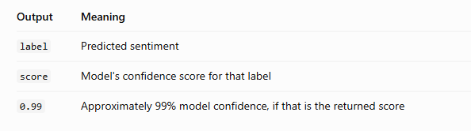
A confidence score is not a guarantee that the prediction is correct.

Step 7 — Experiment with different inputs
Now test multiple sentences.
Python
Run
sentences = [
"This course is very useful.",
"The lecture was boring.",
"The explanation is excellent.",
"I am disappointed with this product.",
"The classroom is large."
]
for sentence in sentences:
prediction = sentiment_analyzer(sentence)[0]
print("Text:", sentence)
print("Predicted label:", prediction["label"])
print("Confidence:", round(prediction["score"], 4))
print("-" * 50)
This is called batch-style experimentation: we use several inputs to examine how the same model behaves.
Expected interpretation:
- Positive statements should generally receive the POSITIVE label.
- Negative statements should generally receive the NEGATIVE label.
- Neutral statements may be classified as either positive or negative because this model only has two classes.

Step 8 — Evaluate the model
Let us provide the correct labels for a small test dataset.
Python
Run
from sklearn.metrics import accuracy_score
from sklearn.metrics import classification_report
texts = [
"I love this course.",
"This is a terrible experience.",
"The teacher explains concepts clearly.",
"I hate this product."
]
actual_labels = [
"POSITIVE",
"NEGATIVE",
"POSITIVE",
"NEGATIVE"
]
predicted_labels = [
sentiment_analyzer(text)[0]["label"]
for text in texts
]
accuracy = accuracy_score(
actual_labels, predicted_labels
)
print("Actual:", actual_labels)
print("Predicted:", predicted_labels)
print("Accuracy:", accuracy)
print(classification_report(
actual_labels,
predicted_labels,
zero_division=0
))
Install scikit-learn first if necessary:
Python
Run
!pip install -q scikit-learn

Accuracy calculation
Suppose the model correctly classifies 4 out of 4 test examples.
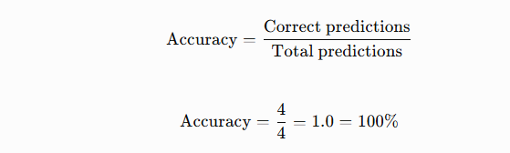
This is an illustration, not a claimed result from the actual model. A four-example test is also far too small to establish general performance.
Important: use a larger, representative test dataset for a meaningful evaluation.

4. Experiment 2: Text generation using GPT-2
Now we will experiment with a generative language model. Unlike DistilBERT sentiment classification, GPT-2 predicts and generates the next tokens.

Step 1 — Load GPT-2
Run this in a new Colab cell.
Python
Run
from transformers import pipeline
generator = pipeline(
"text-generation",
model="openai-community/gpt2"
)
The model is downloaded and loaded into the runtime. GPT-2 is relatively small compared with modern multi-billion-parameter LLMs, making it suitable for an introductory experiment.

Step 2 — Generate text
Python
Run
prompt = "Artificial Intelligence is"
output = generator(
prompt,
max_new_tokens=40,
do_sample=False
)
print(output[0]["generated_text"])
The generated continuation depends on the model. For example, it might begin with a phrase such as “a field of computer science…”, but do not expect an exact predetermined sentence.

Step 3 — Understand the parameters
|
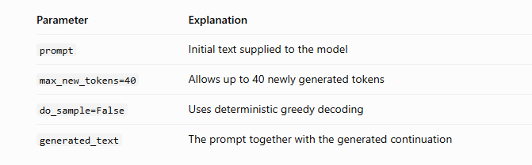The Hugging Face pipeline supports multiple task types and generation settings.

Step 4 — Compare different prompts
Python
Run
prompts = [
"Machine learning is",
"Generative AI can",
"The future of education"
]
for prompt in prompts:
result = generator(
prompt,
max_new_tokens=30,
do_sample=False
)
print(result[0]["generated_text"])
print("-" * 60)
Observe how the output changes when the prompt changes. This is a basic prompt experiment.

Step 5 — Experiment with generation settings
Python
Run
prompt = "A student learning AI should"
for temperature in [0.3, 0.7, 1.0]:
result = generator(
prompt,
max_new_tokens=40,
do_sample=True,
temperature=temperature,
top_k=50
)
print("Temperature:", temperature)
print(result[0]["generated_text"])
print("-" * 50)
Here, temperature affects the randomness of token selection:
- Lower temperature: tends to favor higher-probability tokens.
- Higher temperature: allows more variation.
- top_k=50: restricts sampling to the 50 highest-scoring candidate tokens at each generation step.
The exact behavior depends on the model and the other generation settings. Run the experiment several times to observe variation.

Part B — LangChain: Connecting models to applications

5. What is LangChain?
LangChain is a framework for building applications around language models. It helps connect a model to prompts, documents, retrieval systems, and other application components.
A simple LangChain workflow looks like this:
1. User question
What is machine learning?
2. Prompt template
Formats the question consistently
3. Language model
Hugging Face model generates a response
4. Output
Answer returned to the application
We will connect LangChain to a small Hugging Face model, so you can see how the two tools work together.

6. Experiment 3: Build a question-answering application
For this example, we will use google/flan-t5-small, an instruction-tuned text-to-text model. It is useful for demonstrations on a modest runtime, although its answers may be limited.

Step 1 — Install LangChain and its Hugging Face integration
In a new Colab cell, run:
Python
Run
!pip install -q -U transformers torch langchain-core langchain-huggingface
The important packages are:
- langchain-core: prompt templates and runnable components.
- langchain-huggingface: integration between LangChain and Hugging Face.
- transformers: loads the model.
- torch: runs the neural network.
The current LangChain integration provides HuggingFacePipeline for connecting local Transformers pipelines to LangChain.

Step 2 — Import the components
Python
Run
from langchain_core.prompts import PromptTemplate
from langchain_huggingface import HuggingFacePipeline
PromptTemplate creates a reusable prompt with variables.
HuggingFacePipeline makes the Hugging Face model available as a LangChain component.

Step 3 — Load the language model
Python
Run
model_id = "google/flan-t5-small"
llm = HuggingFacePipeline.from_model_id(
model_id=model_id,
task="text2text-generation",
pipeline_kwargs={
"max_new_tokens": 100,
"do_sample": False
}
)
print("LangChain model loaded!")
Explanation:
- model_id: identifies the model to download.
- task="text2text-generation": specifies a model that generates output text from input text.
- max_new_tokens: limits the generated answer.
- do_sample=False: makes decoding deterministic for the same input and model configuration.
This uses the supported from_model_id interface.

Step 4 — Create a prompt template
Python
Run
template = """
You are an AI teaching assistant.
Answer the following question in simple
language for a B.Tech student.
Question: {question}
Answer:
"""
prompt = PromptTemplate.from_template(template)
The placeholder {question} is replaced with the actual question when the chain runs.
For example:
- Question: What is machine learning?
- The template inserts this question into the prompt.
- The resulting prompt is passed to the model.

Step 5 — Connect the prompt and model
Python
Run
chain = prompt | llm
The | operator connects the two components into a runnable sequence:
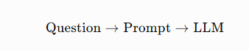
This is known as a LangChain runnable sequence.

Step 6 — Ask a question
Python
Run
question = "What is machine learning?"
answer = chain.invoke({
"question": question
})
print("Question:", question)
print("Answer:", answer)
The output should contain a generated explanation of machine learning. Exact wording will vary, and the small model may produce an incomplete or inaccurate answer.

Step 7 — Ask multiple questions
Python
Run
questions = [
"What is artificial intelligence?",
"What is deep learning?",
"What is a large language model?",
"What is the purpose of a tokenizer?"
]
for question in questions:
answer = chain.invoke({
"question": question
})
print("Q:", question)
print("A:", answer)
print("-" * 60)
You have now built a basic question-answering application using LangChain and a Hugging Face model.

Step 8 — Change the prompt and compare
Try changing the prompt template to:
Python
Run
template = """
Explain the following concept to a beginner.
Give:
1. A definition
2. A real-time example
3. One practical application
Concept: {question}
Explanation:
"""
prompt = PromptTemplate.from_template(template)
chain = prompt | llm
print(chain.invoke({
"question": "Generative AI"
}))
Compare the output with the previous prompt. This experiment demonstrates prompt engineering: changing the instructions while keeping the underlying model the same.

Part C — Complete experimentation workflow

7. How to conduct a proper model experiment
When you conduct an academic lab or research experiment, do not simply run a model once and record its answer. Follow a controlled procedure.
- Define the objective
Example: Determine whether a model can classify student feedback as positive or negative.
- Select the model
Choose a suitable pre-trained model from the Hugging Face Model Hub. Check its task, language, license, and limitations.
- Prepare the data
Create input examples and, for evaluation, their correct labels.
- Run inference
Supply the inputs to the model and store its predictions.
- Change one parameter at a time
Test different prompts, generation lengths, sampling settings, or models.
- Evaluate the results
Use accuracy, precision, recall, F1-score, or task-specific measures as appropriate.
- Record and compare
Save the model ID, settings, test inputs, outputs, runtime, and evaluation results.

8. Hugging Face vs. LangChain
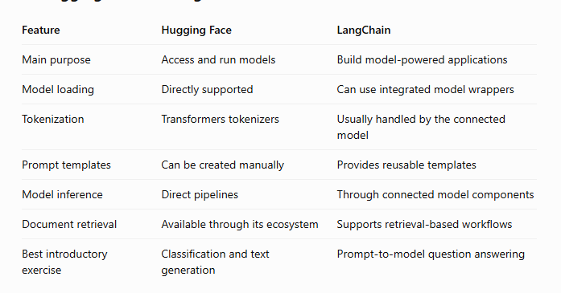The tools are complementary. Hugging Face supplies the model and inference capabilities; LangChain helps organize those capabilities into an application.

